Welcome to our Willing Warriors Retreat Volunteer Platform!
Who We Are
Vision: Through a community effort, serve as the Nation’s leader in caring for our Willing Warriors and their families.
Mission: To provide cost free retreat stays and other programs that positively impact the lives of wounded, ill, and injured military service members, Veterans, and their families.
Interested in learning more about the Willing Warrior Retreat? Click here!

Get Started Today!
- Create your Volunteer Account
- Explore our Programs and Volunteer Opportunities
- Sign up for a volunteer shift! *
You can view this help article for more detailed sign-up instructions.

Download out mobile app!

Once you have successfully created your Volunteer Account (including all Prerequisites) on the website, then you can use the Causer app to Search for Opportunities, Respond, Enter your Hours, etc.
First, you need to download the app from your phone or tablet's app store. Open up your app store and search Causer. You can also scan these QR codes for your specific device to download the app now!


I Have an Account
If you've already registered on an organization's site, use the email address you used to sign up to log into the app. A list of possible sites appears for you to choose from.
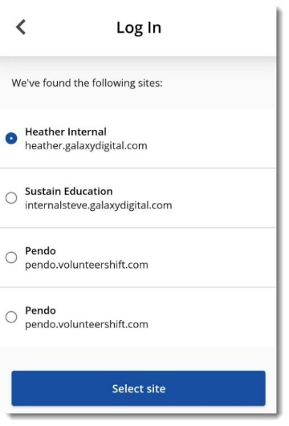
Once you select the site, you're asked to enter your password, or you can select I've forgotten my password to reset it.

You may see some pop-ups depending on what device you're using.
- These can include a Background Location Request pop-up. This helps the app find volunteer Needs or Opportunities near you!
- Another popup you might encounter is a Push Notification Request. Turning this on allows you to receive important notifications from the app about your scheduled volunteer Needs or Opportunities, or other updates from the organization.
- When you have the Background Location and Push Notification enabled, a notification pops up for you to check into a Need or Opportunity when you're close to the listed address for it.
  - Another notification pops up for you to check out when you leave that address.

I Don't Have an Account
If you haven't registered on an organization's site, then you can search for sites near you or search for a site by name.
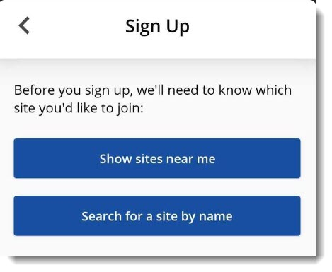
After you select the site you want to sign up for (Willing Warriors), click Sign Up.

Fill out the registration form and click Create my account

Is there training available for volunteers about using this website?
You'll find a ton of articles and videos just for volunteers in the Help Center!

Finding Opportunities with the App
From your dashboard, click Find something to do to start finding Opportunities.
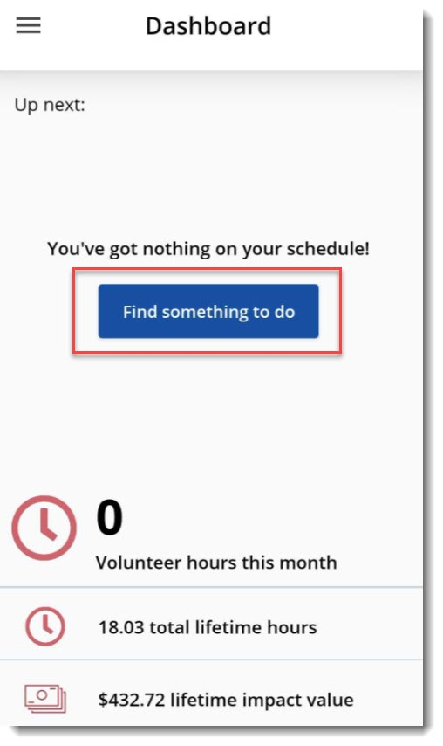
You can also go to the Search area in the app by clicking the hamburger button (☰) in the top left of the app to open your menu.
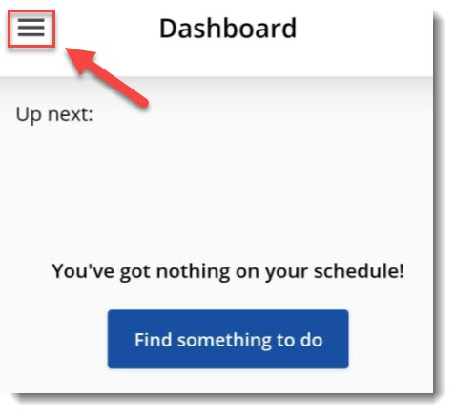

Responding to Needs or Opportunities in the App
After you filter your search and find the Need or Opportunity you want to respond to, click Respond.
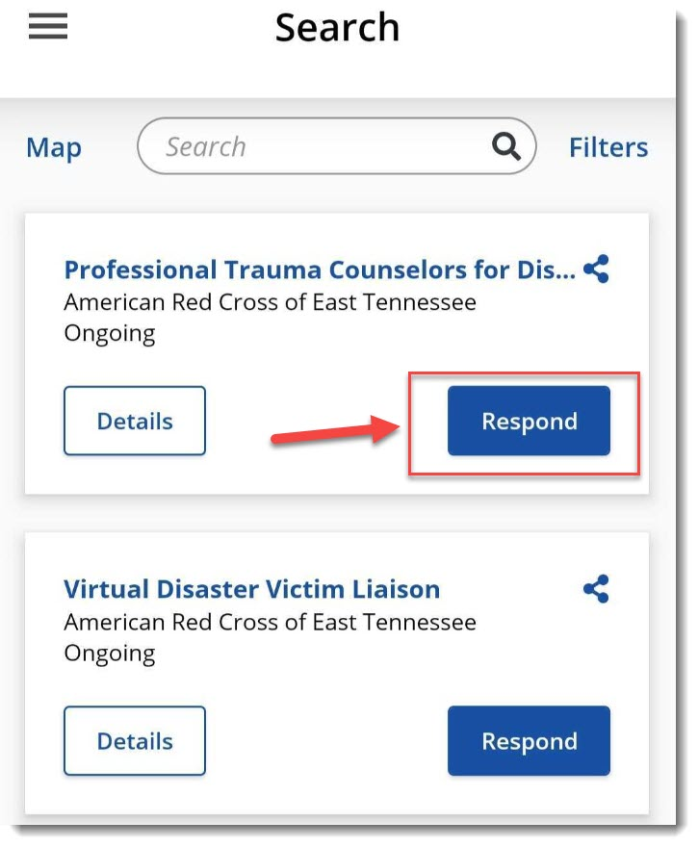
Clicking Respond opens the Opportunity for you to view more details—click Respond again to confirm your selection.

Unregistering From Needs or Opportunities with the App
If you need to unregister for a Need or Opportunity, click on it and select Unregister.
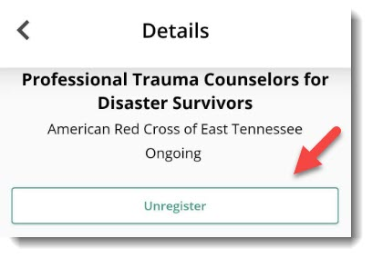

Select the (X) beside the shift you want to unregister for.

Checking Your Schedule in the App
When you first enter the app, your dashboard shows any upcoming volunteer Needs or Opportunities that you're scheduled for.

If you want to see a calendar view of your schedule, click the hamburger button (☰) in the top left corner of the app and select Schedule from the menu.

From here, you can click on a date in the calendar to review details about that specific Opportunity.
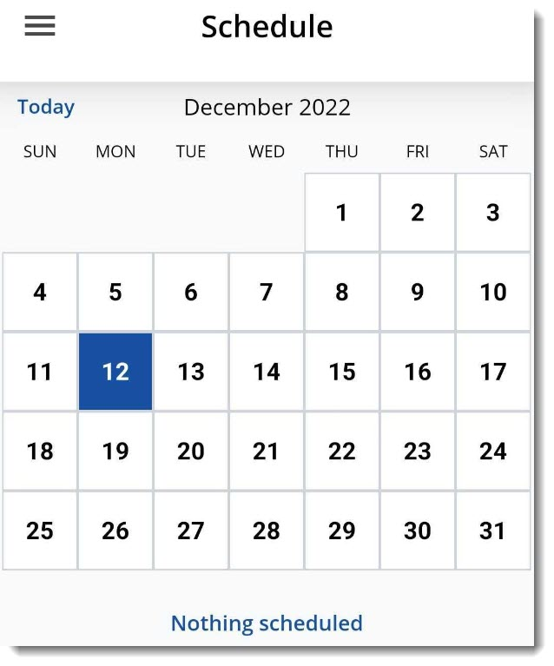

Checking In or Out on the App
If you need to check in or out for a Need or Opportunity, go to the Schedule area in the app and click Check in for the Opportunity.

Adding Hours in the App
If you need to add hours for an Opportunity you volunteered for, then:
- Click the hamburger button (☰) from the top left corner of the app and select Add Hours from the menu.

- You must select the Hours type:
  - For Need or Opportunities you responded to on the site, select Yes.
  - For Need or Opportunities you volunteered for without responding to on the site, select No.
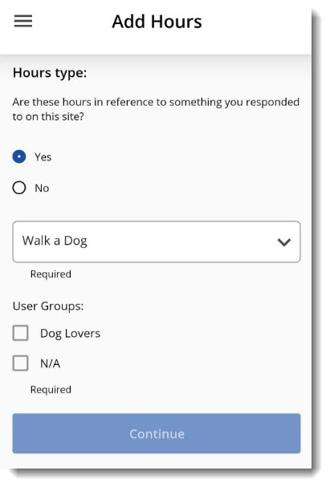
- If you selected yes for the Hours type, then you must choose an Opportunity from the dropdown menu.
- If you completed the Opportunity as a member in a User Group, select the User Group from the options. Select N/A if you weren't part of a User Group.
- Click Continue. Be sure to review your Hour Details and click Submit hours at the bottom of the form to confirm.
  - The only required fields are Date and Hours worked.

